**Wine Quality Prediction – Machine Learning**

Here we will predict the quality of wine on the basis of given features. We use the wine quality dataset available on Internet for free. This dataset has the fundamental features which are responsible for affecting the quality of the wine. By the use of several Machine learning models, we will predict the quality of the wine.

**Importing libraries and Dataset:**

* **Pandas** is a useful library in data handling.
* **Numpy** library used for working with arrays.
* **Seaborn/Matplotlib** are used for data visualisation purpose.
* Sklearn – This module contains multiple libraries having pre-implemented functions to perform tasks from data preprocessing to model development and evaluation.
* **XGBoost** – This contains the eXtreme Gradient Boosting machine learning algorithm which is one of the algorithms which helps us to achieve high accuracy on predictions.

STEP 1:

import numpy as np

import pandas as pd

import matplotlib.pyplot as plt

import seaborn as sb

from sklearn.model_selection import train_test_split

from sklearn.preprocessing import MinMaxScaler

from sklearn import metrics

from sklearn.svm import SVC

from xgboost import XGBClassifier

from sklearn.linear_model import LogisticRegression

import warnings

warnings.filterwarnings('ignore')

Now let’s look at the first five rows of the dataset.

STEP 2:

df = pd.read_csv('winequality.csv')

print(df.head())

**Output:**

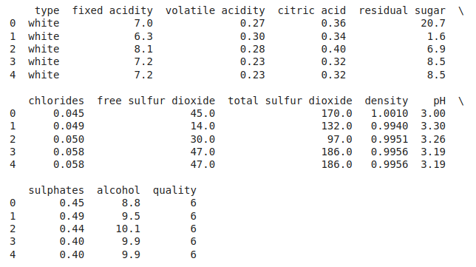

Let’s explore the type of data present in each of the columns present in the dataset.

STEP 3:

df.info()

**Output:**

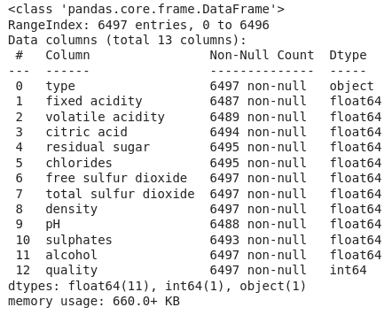

Information about columns of the data

Now we’ll explore the descriptive statistical measures of the dataset.

STEP 4:

df.describe().T

**Output:**

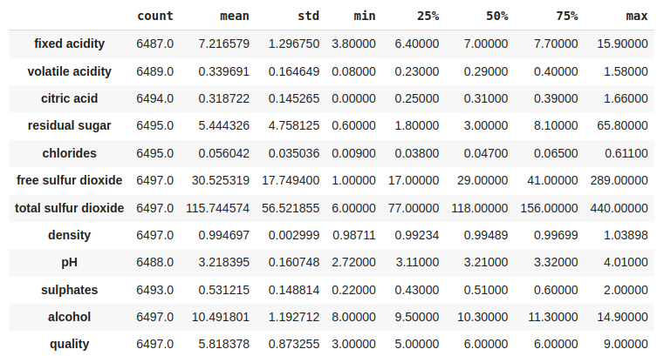

Some descriptive statistical measures of the dataset

**Exploratory Data Analysis**

EDA is an approach to analysing the data using visual techniques. It is used to discover trends, and patterns, or to check assumptions with the help of statistical summaries and graphical representations.  Now let’s check the number of null values in the dataset columns wise.

STEP 5:

df.isnull().sum()

**Output:**

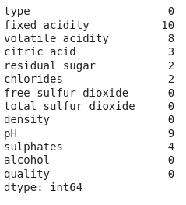

Sum of null values column wise

Let’s impute the missing values by means as the data present in the different columns are continuous values.

STEP 6:

for col in df.columns:

if df[col].isnull().sum() > 0:

df[col] = df[col].fillna(df[col].mean())

df.isnull().sum().sum()

**Output:**

0

Let’s draw the histogram to visualise the distribution of the data with continuous values in the columns of the dataset.

STEP 7:

df.hist(bins=20, figsize=(10, 10))

plt.show()

**Output:**

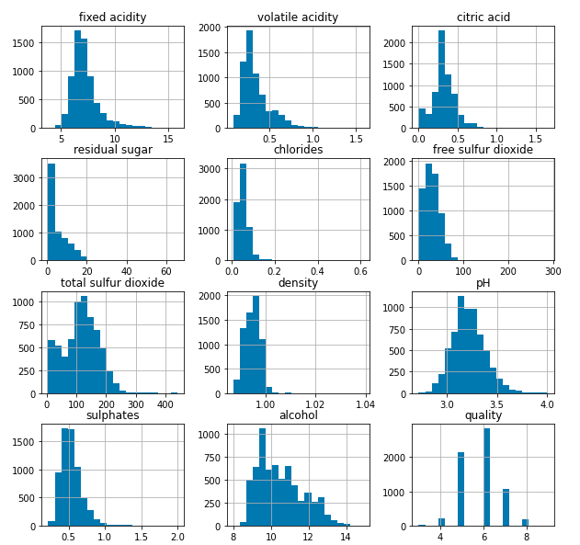

Histograms for the columns containing continuous data

Now let’s draw the count plot to visualise the number data for each quality of wine.

STEP 8:

plt.bar(df['quality'], df['alcohol'])

plt.xlabel('quality')

plt.ylabel('alcohol')

plt.show()

**Output:**

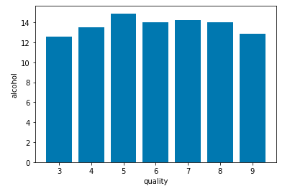

Count plot for each quality of wine

There are times the data provided to us contains redundant features they do not help with increasing the model’s performance that is why we remove them before using them to train our model.

STEP 9:

# Convert 'object' columns to numerical if they represent numbers

for col in df.columns:

if df[col].dtype == 'object':

try:

df[col] = pd.to_numeric(df[col], errors='coerce') # Convert to numeric, replace non-convertibles with NaN

except:

pass # Skip columns that cannot be converted

plt.figure(figsize=(12, 12))

sb.heatmap(df.corr() > 0.7, annot=True, cbar=False)

plt.show()

**Output:**

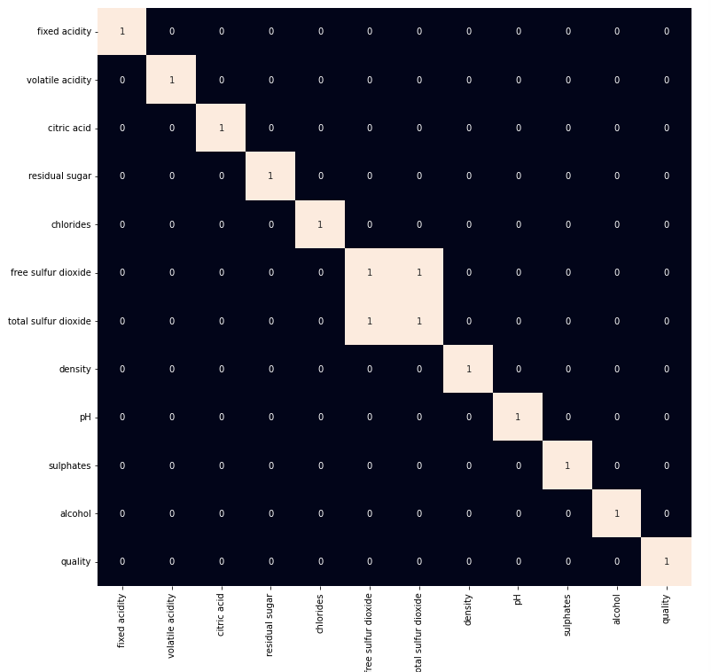

Heat map for highly correlated features

From the above heat map we can conclude that the ‘**total sulphur dioxide’** and ‘**free sulphur dioxide**‘ are highly correlated features so, we will remove them.

STEP 10:

df = df.drop('total sulfur dioxide', axis=1)

**Model Development**

Let’s prepare our data for training and splitting it into training and validation data so, that we can select which model’s performance is best as per the use case. We will train some of the state of the art machine learning classification models and then select best out of them using validation data.

STEP 11:

df['best quality'] = [1 if x > 5 else 0 for x in df.quality]

We have a column with object data type as well let’s replace it with the 0 and 1 as there are only two categories.

STEP 12:

df.replace({'white': 1, 'red': 0}, inplace=True)

After segregating features and the target variable from the dataset we will split it into 80:20 ratio for model selection.

STEP 13:

features = features.fillna(features.mean())

features = df.drop(['quality', 'best quality'], axis=1)

target = df['best quality']

xtrain, xtest, ytrain, ytest = train_test_split(

features, target, test_size=0.2, random_state=40)

# Impute missing values after splitting

from sklearn.impute import SimpleImputer

imputer = SimpleImputer(strategy='mean') # Or another strategy like 'median'

xtrain = imputer.fit_transform(xtrain)

xtest = imputer.transform(xtest)

xtrain.shape, xtest.shape

**Output:**

((5197, 10), (1300, 10))

**Normalising** the data before training help us to achieve stable and fast training of the model.

STEP 14:

norm = MinMaxScaler()

xtrain = norm.fit_transform(xtrain)

xtest = norm.transform(xtest)

As the data has been prepared completely let’s train some state of the art machine learning model on it.

STEP 15:

models = [LogisticRegression(), XGBClassifier(), SVC(kernel='rbf')]

for i in range(3):

models[i].fit(xtrain, ytrain)

print(f'{models[i]} : ')

print('Training Accuracy : ', metrics.roc_auc_score(ytrain, models[i].predict(xtrain)))

print('Validation Accuracy : ', metrics.roc_auc_score(

ytest, models[i].predict(xtest)))

print()

**Output:**

LogisticRegression() :   
Training Accuracy : 0.6975101024661644  
Validation Accuracy : 0.6855058693719925  
  
XGBClassifier() :   
Training Accuracy : 0.9762240429934201  
Validation Accuracy : 0.8045662590288206  
  
SVC() :   
Training Accuracy : 0.7203202525576721  
Validation Accuracy : 0.7073819229472522

**Model Evaluation**

From the above accuracies we can say that Logistic Regression and SVC() classifier performing better on the validation data with less difference between the validation and training data. Let’s plot the confusion matrix as well for the validation data using the Logistic Regression model.

STEP 16:

from sklearn.metrics import confusion_matrix, ConfusionMatrixDisplay

import matplotlib.pyplot as plt

# Assuming 'models[1]' is your trained classifier

cm = confusion_matrix(ytest, models[1].predict(xtest))

disp = ConfusionMatrixDisplay(confusion_matrix=cm, display_labels=models[1].classes_) # Assuming your model has a 'classes_' attribute

disp.plot()

plt.show()

**Output:**

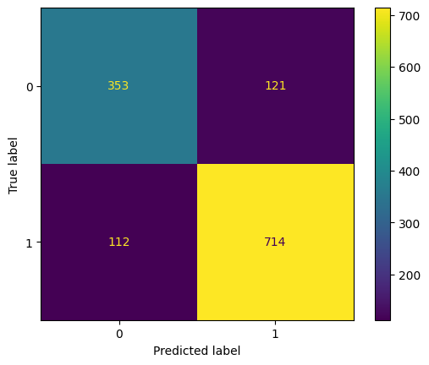

Confusion matrix drawn on the validation data

Let’s also print the c**lassification report** for the best performing model.

STEP 17:

print(metrics.classification_report(ytest,

models[1].predict(xtest)))

**Output:**

precision recall f1-score support  
  
 0 0.76 0.74 0.75 474  
 1 0.86 0.86 0.86 826  
  
 accuracy 0.82 1300  
 macro avg 0.81 0.80 0.81 1300  
weighted avg 0.82 0.82 0.82 1300